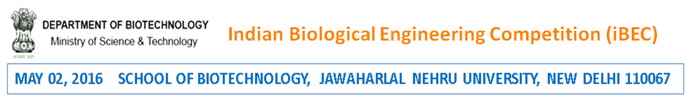
May 23, 2016 School of Biotechnology, Jawaharlal Nehru University, New Delhi 110067
Registration form : pre iGEM competition 2016
[to be filled up Faculty Mentor]

IMPORTANT: READ GUIDELINES ON THE WEBSITE BEFORE FILLING UP THE FORM

SECTION I: GENERAL INFORMATION

- Date of submission _________________________________

- Instructor/Team Leader (name, address, email, phone)
You may change the size of the box based on your requirements. Be specific.

- Student Team (max team size: 5)

S.No. | Name | Affiliation | Email | Phone
1
2
3
4
5

SECTION II: RESEARCH PROPOSAL

- Title of the project
You may change the size of the box based on your requirements. Be specific.

- Aim
You may change the size of the box based on your requirements. Be specific.

- Potential application
(it is expected that the work will be pursued till a certain technological endpoint)
You may change the size of the box based on your requirements. Be specific.

- Technical details

  - Materials (list the pre-existing iGEM parts used, use of iGEM parts is mandatory)
You may change the size of the box based on your requirements. Be specific.

  - Method (with supporting figures, attached separately)
You may change the size of the box based on your requirements. Be specific.

  - Preliminary results (with supporting figures, attached separately)
You may change the size of the box based on your requirements. Be specific.

  - Experiments planned (till the iGEM competition)
You may change the size of the box based on your requirements. Be specific.

- Does the project involve the use of humans, animals or biohazardous materials?
Yes / No (If yes, attach the Certificate of Approval) _________________________

- Total cost (in Rs.) (only recurring cost will be supported) ______________________________________________

- Breakup (Please provide details of items, cost and justification)

S. No. | Item | Cost (in Rs.) | Justification

SECTION III: ADMINISTRATIVE

(note: multi institutional projects are not allowed)

- Details of the executive Authority of the Institute/University forwarding the application
You may change the size of the box based on your requirements. Be specific.

- Duration for which financial support is required
[month / year] to [month / year]
- Relevant Experience of the Instructor/Team Leader
You may change the size of the box based on your requirements. Be specific.

- Any other relevant information, not covered above
You may change the size of the box based on your requirements. Be specific.

